|  |  |  |  |
| --- | --- | --- | --- |
|  |  | A/HRC/33/38 | |
|  | **Advance edited version** | | Distr.: General  4 August 2016  Original: English |

**Human Rights Council**  
**Thirty-third session**

Agenda items 2 and 10

**Annual report of the United Nations High Commissioner   
for Human Rights and reports of the Office of the   
High Commissioner and the Secretary-General**

**Technical assistance and capacity-building**

Situation of human rights in Yemen

Report of the United Nations High Commissioner for Human Rights[1]*

|  |
| --- |
| *Summary* |
| The present report is submitted pursuant to Human Rights Council resolution 30/18. In the report, the United Nations High Commissioner for Human Rights provides an overview of the extent and quality of the cooperation between the national commission of inquiry and the Office of the United Nations High Commissioner for Human Rights. He also describes alleged violations and abuses of international human rights law and alleged violations of international humanitarian law by parties to the ongoing conflict. The High Commissioner concludes the report with recommendations for the parties to the conflict in Yemen. |
|  |

Contents

*Page*

I. Introduction and mandate 3

II. Methodology 3

III. Legal framework 4

IV. Context 5

V. Cooperation with the national commission of inquiry 5

VI. Allegations of violations and abuses 6

A. Military operations 6

B. Sieges and blockades 14

C. Attacks on objects benefiting from special protection 14

D. Freedom of expression 16

E. Deprivation of liberty 17

F. Killings 18

G. Impact on children 18

H. Sexual and gender-based violence 20

I. Forced displacement and eviction 20

VII. Conclusions and recommendations 21

Annexes

I. Additional information on political developments and humanitarian conditions 23

II. Infographs 32

III. United Nations Educational, Scientific and Cultural Organization list of cultural sites  
 in Yemen that have been damaged 35

I. Introduction and mandate

1. In its resolution 30/18, the Human Rights Council requested the United Nations High Commissioner for Human Rights to provide technical assistance and to work with the Government of Yemen, as required, in the field of capacity-building, and to identify additional areas of assistance to enable Yemen to fulfil its human rights obligations, and specifically requested the Office of the United Nations High Commissioner for Human Rights (OHCHR) to assist the national independent commission of inquiry in meeting its work in accordance with international obligations, as mandated in Presidential Decree 140 of 22 September 2012. It requested the High Commissioner to present to the Council, at its thirty-first session, an oral update on the situation of human rights in Yemen, and to present to the Council, at its thirty-third session, a written report on the development and implementation of the resolution. In the resolution, the Council expressed deep concern at the serious abuses and violations of international human rights law and international humanitarian law in Yemen.

2. In the present report the High Commissioner provides an overview of the extent and quality of the cooperation between the national commission of inquiry and OHCHR. After initial difficulties, OHCHR provided the national commission with technical assistance. At the time of the drafting of the present report, however, the national commission had not provided information on its methodology or findings. In the absence of adequate documentation by the national commission, the High Commissioner has outlined in the report a number of allegations relating to violations in order to substantiate his recommendations to the Human Rights Council. The allegations include violations and abuses of international human rights law and violations of international humanitarian law; in particular those relating to the impact of attacks on the population in Yemen, the recruitment of children for their use in hostilities, and violations of freedom of expression that allegedly took place between 1 July 2015 and 30 June 2016.

II. Methodology

3. In order to fulfil its promotion and protection mandate, OHCHR has deployed 29 human rights officers in Yemen: 22, based in 10 governorates,[2] and 7 in Sana’a city. OHCHR has also established a support team in the region in accordance with resolution 30/18.

4. OHCHR provides technical assistance, carries out capacity-building, and monitors violations and abuses of international human rights law and violations of international humanitarian law. During the reporting period, the ongoing armed conflict and security challenges continued to seriously compromise progress on a range of human rights activities that OHCHR has been carrying out in coordination with the Government of Yemen.

5. With regard to monitoring, OHCHR interviews victims and witnesses of alleged violations and abuses, including eyewitnesses, survivors, victims’ family members and activists. OHCHR monitors conduct site visits to document the allegations of violations, and also review reports and meet with the relevant authorities in order to obtain information. In circumstances where monitors are denied access to the site of an alleged violation and to the relevant victims and witnesses, they endeavour to reach those victims and witnesses in other ways, duly considering the impact on the weight information so obtained could be given.

6. In preparing the present report, OHCHR sent letters to a broad range of Governments and organizations, including civil society organizations and human rights organizations in Yemen and a range of international organizations. The Office received and duly considered all the information it received in response, including information from the Government of Yemen and the Government of Saudi Arabia and from national political organizations, civil society organizations and human rights organizations.[3] Where the report includes data or statistics gathered by credible partner organizations, including official bodies, intergovernmental and non-governmental organizations, and the media, the source of the information is clearly cited, and it is indicated whether OHCHR was able to corroborate the information.

7. OHCHR employs a “reasonable ground” standard in its assessment of incidents investigated. The assessment in each case considers the credibility and reliability of the source, taking into account its nature and objectivity, the quality of previously submitted information and the methodology utilized by the source, and the validity of the information itself, which is cross-checked through witness statements and other sources of information.

III. Legal framework

8. Yemen is a party to seven of the nine core international human rights treaties and to the Optional Protocols to the Convention on the Rights of the Child on the involvement of children in armed conflict and on the sale of children, child prostitution and child pornography. As a party to those instruments, Yemen is legally bound to respect, protect and fulfil the human rights of those within its jurisdiction. Despite approval by the Cabinet, the Parliament has yet to approve the ratification of a number of human rights instruments, namely, the International Convention for the Protection of All Persons from Enforced Disappearance, the Rome Statute of the International Criminal Court, the Optional Protocol to the Convention against Torture and Other Cruel, Inhuman or Degrading Treatment or Punishment and the Protocol to Prevent, Suppress and Punish Trafficking in Persons, Especially Women and Children, supplementing the United Nations Convention against Transnational Organized Crime.

9. Yemen is a party to all four Geneva Conventions of 12 August 1949 and to Additional Protocols I and II thereto, and to the Convention on Prohibitions or Restrictions on the Use of Certain Conventional Weapons Which May Be Deemed to Be Excessively Injurious or to Have Indiscriminate Effects. Yemen has not accepted individual complaints procedures provided for under the various international human rights treaties, with the exception of the procedure provided for under the Optional Protocol to the Convention on the Rights of Persons with Disabilities.

10. All parties to the conflict in Yemen, including members of the coalition forces,[4] are obliged to respect the applicable rules of international humanitarian law, including the principles of precaution, distinction and proportionality. Civilians and civilian objectives must be protected at all times. Hospitals, schools and religious sites are subject to heightened protections; attacks on them have an impact on peoples’ enjoyment of their rights, including to health, education and freedom of religion. Parties to the conflict must allow and facilitate rapid and unimpeded passage of impartial humanitarian relief for civilians in need. It is increasingly accepted that non-State actors that exercise government-like functions and de facto control over a territory must respect human rights standards when their conduct affects the human rights of the individuals under their control.

IV. Context[5]

11. Since 2011, Yemen has been the theatre of a number of simultaneous and overlapping armed conflicts. In the present report, the High Commissioner focuses principally on the conflict between, on the one hand, forces loyal to President Abd Rabbo Mansour Hadi, supported by the coalition forces and, on the other, the Popular Committees affiliated with the Houthis and the army units loyal to former President Ali Abdullah Saleh. This has been the predominant conflict in Yemen during the time frame covered by the present report, and the most consequential in terms of overall impact on the civilian population and the country’s fragile infrastructure. The conflict has, to some extent, encompassed pre-existing conflicts, such as those between the armed groups of the Islah Party and pro-Houthi armed groups; and the armed groups affiliated with the Hirak Party against the 33rd Armoured Brigade, led by Brigadier General Abdullah Dhabaan, whose forces are affiliated with the pro-Saleh army units.

12. During the period covered by the report, the situation in Yemen deteriorated significantly. The ongoing attacks from the ground and the air have continued to inflict heavy casualties, caused extensive damage to public and private infrastructure and frequently impeded the rapid passage of humanitarian relief for civilians in need.

13. Between 1 July 2015 and 30 June 2016, OHCHR documented 2,067 civilians killed and 2,815 injured as a result of the conflict. Of those, 1,259 civilians were allegedly killed and 1,360 injured as a result of air strikes by the coalition forces, 475 civilians were allegedly killed and 1,121 injured as a result of shelling by the Popular Committees and army units loyal to former President Saleh and 113 civilians were allegedly killed and 154 injured as a result of attacks by armed groups affiliated with Al-Qaida and so-called Islamic State in Iraq and the Levant (ISIL). Others were killed and injured by unidentified armed groups. That brings the total number of documented civilian casualties to 3,591 killed and 6,360 injured since the intensification of the conflict on 26 March 2015.[6]

V. Cooperation with the national commission of inquiry

14. On 7 September 2015, President Hadi issued presidential decree No. 13, amending presidential decree No. 140 of 22 September 2012, and thereby appointing the nine members of the national commission of inquiry to investigate allegations of human rights violations that have been reported since 2011, in accordance with Human Rights Council resolutions 24/32 and 27/19. Following the resignation of three of the appointed members and the death of another, on 10 May 2016 the President appointed four new members.

15. In accordance with the request, contained in Council resolution 30/18, that OHCHR assist the national commission, the Office promptly undertook a number of actions. It deployed three experts in international human rights law and international humanitarian law to Amman to provide the national commission with capacity-building assistance; held meetings with representatives of the national commission in Geneva from 7 to 11 March 2016 in order to clarify the nature of the cooperation between OHCHR and the commission; provided the national commission with manuals and other tools, in Arabic and English, relating to methodological standards, human rights investigations and international humanitarian law; and sent online questionnaires and surveys to members of the national commission and its field monitors in order to assess the needs of the national commission and to develop customized capacity-building activities.

16. Following the initial difficulties faced by OHCHR in receiving information from the national commission, cooperation noticeably improved following a clarification meeting with the presiding judge of the commission, held in Amman on 12 May 2016. Owing to the security challenges of organizing a workshop in Aden, OHCHR moved to Amman the location of a workshop for field monitors of the national commission; the workshop was successfully held from 2 to 5 June 2016, with 26 field monitors attending. A seminar with the experts of the national commission had been scheduled to take place in Amman in July 2016. Unfortunately, owing to security and logistical reasons it was cancelled, despite the readiness to attend expressed by OHCHR and the experts.

17. The High Commissioner understands that, since its inception, the national commission has faced a number of challenges, notably owing to the dire security context and the lack of cooperation with and recognition of the national commission by some of the parties to the conflict. At the time of the drafting of the present report, the national commission has not provided OHCHR with information on its methodology and findings or on its progress in carrying out comprehensive and impartial inquiries.

VI. Allegations of violations and abuses

A. Military operations

18. OHCHR has documented substantial allegations concerning possible violations of international humanitarian law in the context of the conduct of hostilities in Yemen during the reporting period. In several of the documented attacks, OHCHR was unable to identify the presence of possible military objectives. In numerous situations where military targets could be identified there remain serious concerns as to whether the incidental loss of civilian life, injury to civilians and damage to civilian objects that could be expected from the attack were not excessive in relation to the anticipated concrete and direct military advantage apparently sought.

1. Attacks affecting civilians and civilian objects carried out by the Popular Committees affiliated with the Houthis and army units loyal to former president Saleh

(a) Attacks on residential areas[7]

19. OHCHR has documented recurrent attacks striking civilians and civilian objects, including in residential areas, carried out by the Popular Committees and the army units loyal to former President Saleh. The deadliest of those was the attack on the Al-Ghaleel residential neighbourhood in the Dar Sa’ad District, Aden, on 19 July 2015 (see figure VI[8]). As a result of that attack, 107 civilians, including 29 children and 32 women, were killed, 198 civilians, including 28 children and 42 women, were injured and 14 civilian homes were destroyed. Witnesses and residents of Al-Ghaleel told OHCHR that the neighbourhood was inhabited primarily by the marginalized Muhamasheen community.

Figure 1  
Examples of the destruction incurred in the Dar Sa’ad District on 19 July 2015

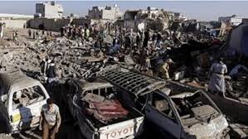 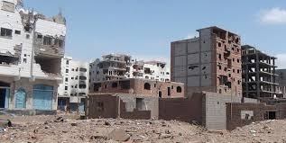 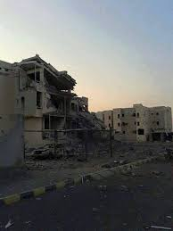 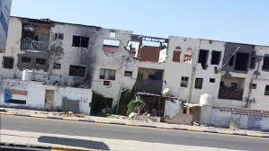

20. A series of rocket and mortar attacks affecting residential areas and markets took place in Taizz between 3 and 8 June 2016, killing 18 civilians, including 7 children, and injuring 68 others. According to several victims injured during an attack near the Deluxe Market on 3 June, the shelling originated from Tabat Al-Sofitel hill, in the eastern part of Taizz city, which was under the control of the Popular Committees and forces loyal to Saleh. The shelling on civilian areas continued until the evening of 4 June and restarted on 6 June, when several houses in the Al-Ta’iziyah and Al-Qahirah districts were hit, killing 3 civilians and injuring 12 others, including 9 children.

21. On 14 August 2015, the Popular Committees bombed three houses reportedly belonging to prominent members of the Islah Party in Othmah District, Dhamar Governorate. Witnesses stated that about 20 members of the Popular Committees placed and detonated improvised explosive devices on the premises of a residence housing four families, destroying the house and its holdings. On 11 September 2015, the home of a prominent Islah leader was blown up in the village of Al-Jaws Bani Wael in Ibb Governorate. Witnesses told OHCHR that on several occasions the Popular Committees had threatened to destroy the homes of residents suspected of sympathizing with Colonel Abdul Wahhab al-Waeli. This campaign of intimidation by the Houthis led to extensive displacement among the local populations, particularly in Udayn District, Ibb. The inhabitants of the bombed homes had been evacuated prior to their destruction.

(b) Allegations of use of landmines

22. OHCHR documented cases in which civilians had allegedly been killed or injured by landmines in areas controlled by pro-Houthi and pro-Saleh armed groups. The Office was unable to verify when the mines had been laid. In one incident, on 14 August 2015, a child was killed and two civilians injured as a result of a landmine detonation in the Abeed valley, Serwah District, near the main road between Mareb and Sana’a. A similar incident occurred on 23 September 2015, when six civilians, including two children, were killed and two women injured as a result of a landmine detonating in the Al-Dhabab area near Taizz.

(c) Sniper attacks

**23.** OHCHR documented incidents in which civilians had allegedly been shot at by snipers positioned in areas and buildings controlled by the Popular Committees. On 12 September 2015, an 8-year-old girl was shot and killed by a sniper on Arba’en Street in Taizz. Witnesses said that her relatives had been unable to immediately rush to her rescue because of continuing shooting by snipers, and that Popular Committee fighters had been positioned on nearby rooftops.

2. Air strikes by the coalition forces affecting civilians and civilian objects

24. OHCHR has documented incidents in which air strikes by the coalition forces had an impact on localities with a high concentration of civilians, including markets and residential areas, as well as on events such as wedding ceremonies, frequently incurring high casualties and causing substantive infrastructural damage. The cases monitored by the Office indicate that air strikes were the single largest cause of casualties, resulting in approximately one third of the deaths and injuries recorded by OHCHR.

(a) Attacks on markets[9]

25. OHCHR documented five attacks on markets during the period covered by the report, which collectively incurred the killing of 269 civilians; 124 civilians were injured. The following are the gravest and most representative attacks. On 15 March 2016, the coalition forces launched two air strikes on Khamees market in Mastaba District, Hajjah, during peak hours (see figure II). As a result, 107 civilians, including 25 children, were killed and 37 civilians, including 4 children and 1 woman, were injured. A total of 16 shops were destroyed. Several witnesses interviewed by OHCHR hours after the attack stated that, at the time of the attack, there was a military checkpoint manned by four to six officers from the police and members of the Popular Committees about 250 metres from the market. The witnesses also stated that no warning had been given to the civilians in the area prior to the attacks.

Figure II  
Damage to the Khamees market

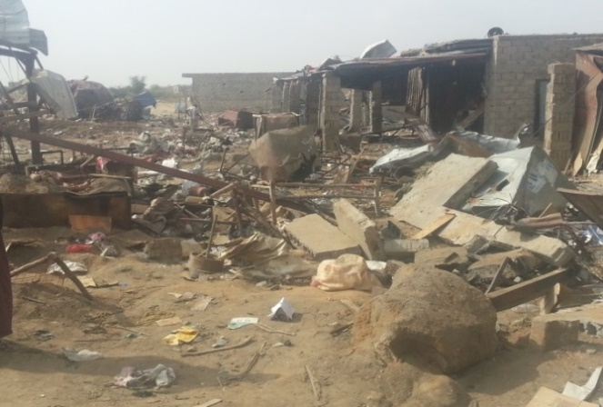 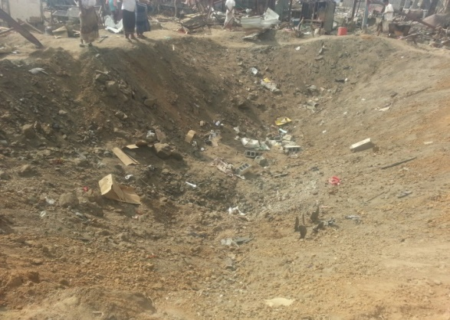

26. On 27 February 2016, an air strike by the coalition forces hit the Khaleq market in Nahm District, Sana’a Governorate, killing 41 civilians, including 9 children and 4 women, and injuring 33 others, including 6 children and 3 women. According to first-hand accounts of local residents interviewed by OHCHR, most of those killed and injured were shop owners working at the market and clients shopping at the time of the attack. OHCHR could not verify the presence of any military objects within the immediate proximity of the market.

(b) Attacks striking weddings[10]

27. OHCHR documented attacks by the coalition forces that struck two wedding ceremonies. According to numerous witnesses interviewed and information gathered by OHCHR, 80 civilians, including 32 women and 38 children, were killed and 40 injured as a result of air strikes that hit a wedding ceremony in Al-Mokha District, Taizz Governorate, on 24 September 2015. Witnesses told OHCHR that they heard the loud reverberations of military aircraft flying at low altitudes at about 9.30 a.m., followed by the first two missiles, which hit a tent that was hosting the male guests. Moments later, witnesses stated that the tent hosting the female guests, located some 50 metres away, was struck by a third missile. Remnants of the missiles partially destroyed a house located approximately 7 metres away, causing the deaths of two civilians.

(c) Attacks on residential buildings[11]

28. OHCHR has documented incidents where the coalition forces are alleged to have targeted the homes of individuals affiliated with the Houthis, relatives of former President Saleh and other individuals with no publicly known political affiliation. Many of those attacks resulted in the killing or serious injury of civilians. Two of the most salient such attacks are listed below.

29. On 20 August 2015, air strikes by the coalition forces hit homes located between 5 and 120 metres from the palace of former President Saleh in Taizz, killing 53 civilians, including 28 children and 12 women, and injuring 11 others. Local residents and eyewitnesses indicated that the palace may have been being used for military purposes by the Popular Committees at the time of the attack. If that was the case, then the palace may have been a military objective. Nonetheless, OHCHR did not obtain any information regarding precautionary measures that may have been taken; in particular, according to residents who spoke to OHCHR, no warning was issued to local residents.

30. On 24 January 2016, a judge and seven members of his family, including three women and three children, were killed and five others injured when an air strike by the coalition forces hit their three-storey house in the Nahdah neighbourhood on the outskirts of Sana’a city and destroyed eight neighbouring houses. According to witnesses, including two bodyguards who survived the attack, an aircraft had hovered over the judge’s house and, after a few minutes, two missiles had struck the house, causing the reported casualties.

(d) Attacks on public and private infrastructure[12]

31. OHCHR investigated numerous aerial attacks by the coalition forces against civilian objects that resulted in the killing and serious injury of large number of civilians and the partial or total destruction of public and private infrastructure.

32. On 24 July 2015, a coalition air strike hit the residential compounds of the Mokha Steam Power Plant in Mokha District, Taizz, killing 73 civilians, including 13 women and 11 children, and injuring 93 others. Eyewitnesses told OHCHR that the two residential compounds were being used to house the plant workers and their family members. One of the compounds lies approximately 500 metres from the power plant while the second is about 1 kilometre away. OHCHR was informed that the aerial attacks struck two apartment buildings situated nearby, causing substantial damage. Witnesses stressed that there were no military targets within the vicinity of the compound at the time of the attack.

(e) Allegations of the use of cluster bombs

33. OHCHR found credible allegations concerning the use of cluster bombs by the coalition forces and the use of landmines by the pro-Houthi armed groups and pro-Saleh army units. OHCHR notes that neither Yemen nor Saudi Arabia are parties to the Convention on Cluster Munitions; Yemen has ratified the Convention on the Prohibition of the Use, Stockpiling, Production and Transfer of Anti-Personnel Mines and on Their Destruction. Although the use of cluster bombs has not been banned by those States, their use in civilian residential areas, particularly in the absence of precautionary measures, may amount to violations of international humanitarian law, in the light of the inherently indiscriminate nature of such weapons.[13]

34. In December 2015, allegations of use of cluster bombs by the coalition forces arose. OHCHR verified reports of cluster sub-munitions dropped from the air during attacks on the Hajjah districts of Bakeel al-Meer, Hairan and Haradh. OHCHR interviewed victims and witnesses and carried out field visits to the affected areas and confirmed that six civilians had been wounded as a result of alleged cluster-bomb explosions. The use of such bombs was documented across large expanses of agricultural land in Hajjah (see figure III). OHCHR looked into allegations of the use of cluster ammunitions by the coalition forces that reportedly struck Al-Haima Port and Al-Haima Village in Al-Khokha District, Hodeidah Governorate, on 12 December 2015. According to information gathered by the Office from witnesses, 11 civilians had been wounded when cluster ammunitions reportedly hit five civilian homes in Al-Haima village (see figure IV).

35. On 6 January 2016, similar allegations were raised when two civilians were injured and five residential buildings and seven cars were damaged after the coalition forces allegedly airdropped cluster bombs on residential neighbourhoods in Sana’a (see figures V to VII). According to witnesses interviewed by OHCHR, the attacks were carried out by the coalition forces on Ishreen Street and Al-Ribat Street in Hayal Sayeed neighbourhood and on Al-Rakkas Street, Sita’sh Street and Al-Zira’a Street in Ma’een District. Witnesses told OHCHR that in the early hours of 6 January they started hearing loud explosions from outside their homes. When they went out, they found what appeared to be remnants of cluster bombs. The eyewitnesses also stated that five homes and at least seven cars incurred damages as a result of being hit by fragments from the explosions.

36. On 19 February 2016, the coalition forces allegedly resorted to cluster bombs during air strikes on Al-Marha Mountain and the Al-Mahjar area, south of the Amran cement factory (see figure VIII). As a result, a construction machine belonging to the factory sustained damage.

Figure III  
Remnants of cluster bombs found in the Al-Khadraa area, Hajjah

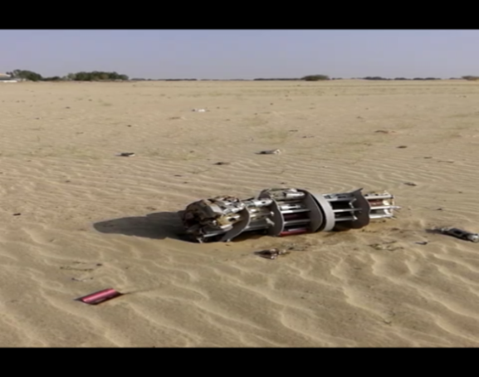 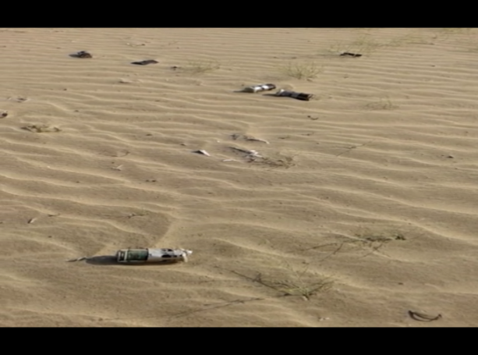

Figure IV  
Remnants of cluster bombs found in Al-Haima village, Hodeidah Governorate, in December 2015

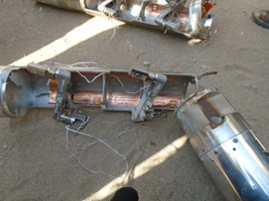 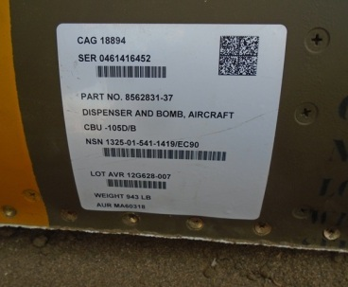

Figure V  
Remnant of a cluster bomb found near al-Zira’a Street in Sana’a city   
on 6 January 2016



Figure VI  
Remnants of sub-munitions found in the Hayal Sayeed neighbourhood of Sana’a city on 6 January



Figure VII  
A car, on Al-Zeraa Street, affected by the attack of 6 January



Figure VIII  
Remnants of a cluster bomb found at the cement factory in Amran in February 2016

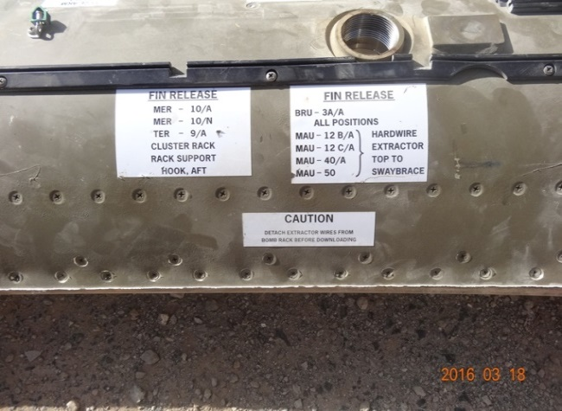 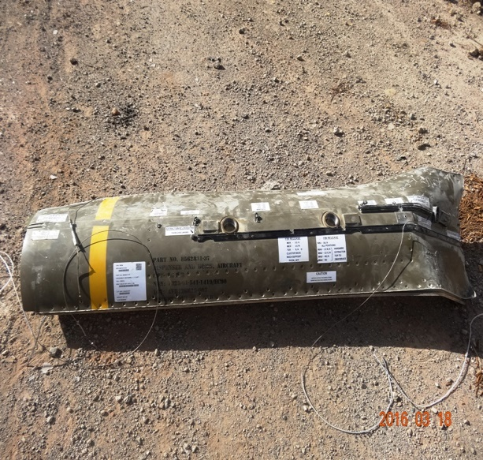

3. Attacks by other armed groups[14]

37. During the reporting period, OHCHR observed a growing number of attacks by armed groups against civilians, including religious leaders, government representatives, members of the State security forces and aid workers. The perpetuation of the conflict has created security vacuums that have been increasingly exploited by armed groups. Most of the attacks documented by OHCHR were carried out by groups manifestly affiliated with Al-Qaida and ISIL; however, some of the attacks were carried out by groups that remain unknown.

38. On 3 February 2016, the convoy of the Security Director of Lahj Governorate was hit by a vehicle-borne improvised explosive device when traveling across the Hay Al-Tayarain neighbourhood in Sheikh Othman District, Aden. The Security Director and five of his body guards were injured, and a child who was standing nearby died as a result of the explosion.On 2 September 2015, two humanitarian workers providing aid to displaced persons in Amran and Sa’ada were killed in Al-Huth District, Amran Governorate. According to a witness, the victims were returning from Sa’ada to Sana’a city when their car was stopped and they were attacked by unidentified gunmen.

39. On 6 September 2015, an officer of the Political Security Department, the son of the Secretary-General of the Hirak Party in Dhale’e, was shot and killed by armed men in Khuarmaksar District, Aden Governorate. Ansar al-Sharia, a local Al-Qaida affiliate, claimed responsibility for the killing over social media. On 3 October 2015, a colonel in the criminal investigations unit was shot in the face and killed by unknown armed men travelling on motorcycles in Sheikh Othman District, Aden. On 6 December 2015 the governor of Aden, Major General Jaafar Mohamed Saad was killed when a parked car was detonated as the governor’s convoy was passing nearby, in the Tawahi District, according to media reports. Ten others were killed in the attack, many of them belonging to the governor’s security detail. ISIL claimed responsibility, through the media, for the attack.

4. Drone attacks

40. According to reports received by OHCHR, two internally displaced persons from Jawf were killed on 3 October 2015 in eastern Mareb by a drone attack. Their funeral on 5 October was struck by another drone, which killed two others. Both attacks were allegedly carried out by the United States Air Force in cooperation with the Government of Yemen as part of their campaign against suspected Al-Qaida affiliates.

41. Media reports indicated that on 22 March 2016, as many as 50 suspected Al-Qaida affiliates may have been killed by a drone strike in Al-Bayda Governorate. OHCHR was unable to verify those allegations or to understand whether civilians may have been killed or injured during the attack. It has been reported that on 27 March 2016, Ansar al-Sharia published a post on social media acknowledging the 22 March attack on its brigade.[15]

B. Sieges and blockades

42. Since August 2015, residents in Taizz have witnessed a serious deterioration of the health situation and a near collapse of the health system as a result of the blockade imposed by the Popular Committees. In August 2015, the Taizz health office reported that, with the exception of the emergency unit and the kidney ward at the Thawra and Al-Jumhurri hospitals, all six public hospitals were no longer operational. Smaller private hospitals with limited capacity have been overwhelmed with the needs of those injured during the fighting. Furthermore, an outbreak of dengue fever exacerbated an already dire health situation for civilians stuck in Taizz; the Taizz health office reported 813 cases of dengue fever during August 2015.

43. OHCHR has observed a continuation of the naval blockade and restrictions on air and land travel imposed by the coalition forces throughout the period under consideration. According to humanitarian actors, the crisis has worsened as the harsh restrictions on imported vital goods have resulted in no fuel for water-pumping stations, hospitals and homes, and in a lack of medicine that has prevented the provision of adequate health care to persons with chronic ailments and those wounded by the violence. In areas under the control of the Houthi and/or Saleh-aligned forces, restrictions have included frequent denials of the movement-of-personnel requests made by humanitarian agencies and refusal to allow aid flows.

C. Attacks on objects benefiting from special protection

44. Medical facilities, as well as educational facilities and religious and cultural sites, have repeatedly come under attack, despite the special protection afforded them. While the coalition forces have reportedly caused damage to protected objects mainly as a result of aerial attacks, the pro-Houthi and pro-Saleh forces have reportedly damaged protected sites through shelling and, at times, by allegedly positioning military objectives within the premises or surroundings of such sites. Al-Qaida and ISIL have carried out attacks on religious and cultural sites.

1. Medical facilities and personnel[16]

45. The following are three salient cases documented by OHCHR involving medical facilities and personnel. In Haydan District, Sa’ada, at around 10.30 p.m. on 26 October 2015, Haydan hospital, which is supported by Médecins sans frontières, was hit by two air strikes. The staff and patients managed to escape the hospital before the second air strike hit. According to Médecins sans frontières, the hospital was providing vital care to approximately 200,000 people in the region and its location coordinates had been shared with the parties to the conflict.

46. On 11 November 2015, Thawra hospital, one of the main health-care facilities in Taizz, was allegedly shelled by members of the Popular Committees (see figure IX), resulting in the killing of a civilian and the injury of eight others, including a medic, and also in structural damage. According to eyewitness accounts, three missiles were launched from Al-Harer hill, which at time of the incident was under the control of the Popular Committees.

Figure IX  
Structural damage incurred by Thawra hospital in Taizz

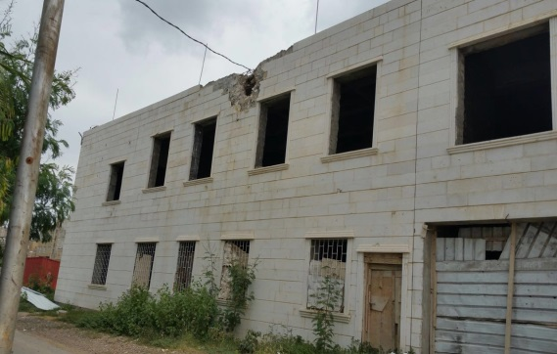

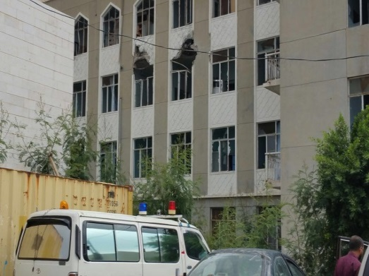 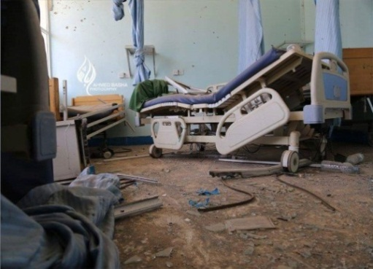

47. On 2 December 2015, a clinic run by Médecins sans frontiers in Houban, Taizz, was hit by a coalition forces air strike, which killed one civilian and wounded nine others, including two children and one woman. On 5 January, an air strike by the coalition forces reportedly hit the Dar al-Noor children’s rehabilitation centre for the blind in Safia, a neighbourhood in Sana’a city, injuring three civilians, including children. Attacks on medical units may amount to war crimes and may constitute a violation of the right to health.[17]

2. Historic or cultural sites and places of worship[18]

48. OHCHR has documented the partial or total destruction of cultural properties. The cases documented include the coalition forces air strike that hit Al-Waht Mosque in Lahj Governorate on 7 July 2015, killing 10 civilians and injuring 15 others; the destruction of the ancient tombs of Hadramaut on 1 July 2015 by armed groups affiliated with Al-Qaida; and the partial destruction of Al-Qahira Castle, one of the country’s most important historic and architectural sites, in August 2015, by the Popular Committees.[19]

3. Educational facilities[20]

49. On 9 July 2015, 10 civilians, including 3 women and 2 children, were killed as a result of an air strike by the coalition forces that hit the Mus’ad Bin Omair School in Tuban District, Lahj. According to eyewitness accounts, the victims were internally displaced persons from Aden who had been seeking shelter in the school premises at the time of the attack. OHCHR found no evidence of any potential military objective in or around the school.

50. On 16 July 2015, Al-Zahra’a University in Sana’a city was hit by an air strike by the coalition forces, killing one child, injuring five other civilians and causing structural damage to the university and to 11 nearby homes. Saba University, also located nearby, incurred partial structural damage.

D. Freedom of expression

51. Attacks on journalists and human rights defenders have continued throughout the reporting period. There have been allegations of, among others, restrictions on freedom of expression, arbitrary deprivation of liberty, unlawful detention, enforced disappearance, intimidation and unlawful killing. The authorities under the control of the Popular Committees have blocked 10 news websites, censored four satellite television channels and blocked five newspapers from going to print.

52. OHCHR documented 10 cases in which the premises of human rights organizations were raided and 4 cases where human rights defenders were banned from traveling outside the country by the de facto authorities under Houthi control. The Office has verified other serious allegations of intimidation targeting political opposition members, including the bombing of the home of a prominent Islah Party figure on 11 September 2015 by the Popular Committees in the village of Jawz Bani Wael, Ibb.

E. Deprivation of liberty[21]

53. In its resolution 30/18, the Human Rights Council expressed its deep concern at the abduction of political activists and the violations against journalists. Since 1 July 2015, OHCHR has verified 491 cases that may amount to deprivation of liberty by the various parties to the conflict (see figure X).[22] Information gathered indicates that 89 per cent of the incidents relating to deprivation of liberty were allegedly committed by the Popular Committees, 6 per cent were attributed to Al-Qaida affiliates and 5 per cent were attributed to the pro-Hadi Popular Resistance Committees. As at 24 March 2016, 249 individuals reportedly deprived of their liberty, including 18 journalists,[23] were in custody in detention centres in various governorates.[24] The whereabouts of four detainees remained unknown, and the cases may amount to disappearances.

54. In Sana’a, OHCHR identified at least eight places of deprivation of liberty operated by the Popular Committees, including Habra, in Al-Shu’aub District; Hataresh, in Bani Hashaysh District, Al-Thawra; and the house of Ali Mohsen al-Ahmar in Haddah. Released individuals told OHCHR that the conditions of their deprivation of liberty were marred by malnutrition, denial of medical care, extremely limited visits and squalid sanitation conditions.

55. In November and December 2015, OHCHR visited places of deprivation of liberty in seven governorates: Aden, Abyan, Hajjah, Hodeidah, Ibb, Sana’a and Shabwah. During the field visits, 56 individuals deprived of their liberty, prisoners and detainees were interviewed individually, as were senior officials in Sana’a city. According to information gathered by OHCHR, as at 31 December 2015, a total of 8,905 individuals were being held by the “rehabilitation and correction authority”.

56. OHCHR has sent 24 letters to various authorities since November 2015, requesting information and expressing its concerns about the fate of the 491 persons who may have been deprived of their liberty, but did not receive any response.[25]

Figure X  
Incidents of deprivation of liberty documented by the Office of the United Nations High Commissioner for Human Rights, by month

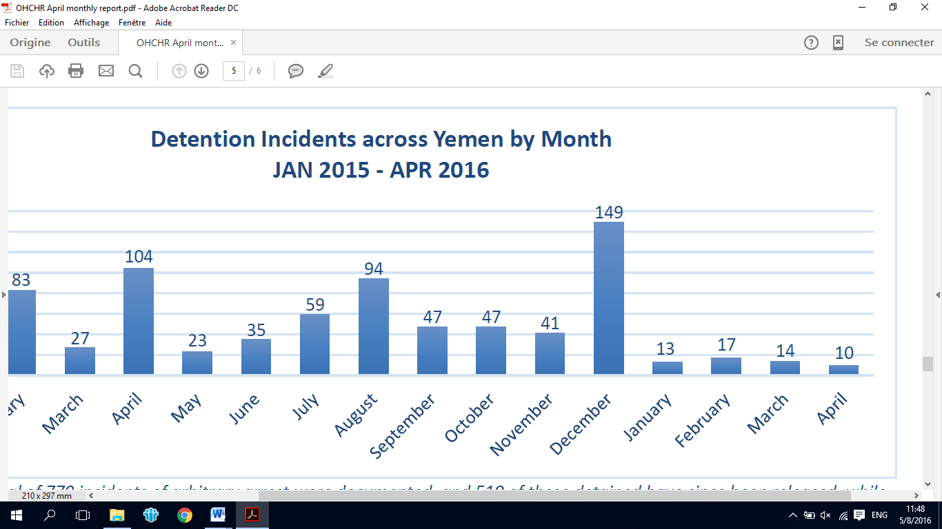

F. Killings

57. During the reporting period, OHCHR recorded the killing of six journalists and 11 attacks in which journalists were injured. It received reports indicating higher figures,[26] but was unable to verify those reports. January 2016 witnessed the highest number of killings since the start of the conflict. OHCHR documented 27 killings in Aden alone. Most of the attacks were perpetrated by unknown armed men or groups affiliated with Al-Qaida or with ISIL and frequently targeted members of the security forces, judicial authorities and civilians.

58. Eyewitnesses stated that on 16 August 2015, the pro-Hadi Popular Resistance Committees allegedly killed a suspected pro-Houthi sniper and put his naked body on public display on Twenty-Six September Street, Taizz city.[27] Local residents stated that the victim was killed while face down and his body was dragged before being hung upside down. In another incident, witnesses stated that on 12 March 2016, a suspected pro-Houthi fighter had been captured near Al-Asbahi store in Al-Saeed neighborhood in Al-Qahirah District, Taizz, and allegedly shot in the head three times by members of the Popular Resistance Committees.

G. Impact on children

59. The ongoing conflict has had a devastating impact on children. Information collected by the country task force on monitoring and reporting[28] suggests that 620 children have been killed and 758 children maimed as a result of fighting since July 2015 (see figure XI).[29] OHCHR has received information indicating that children have been recruited by parties to the conflict, allocated to military checkpoints and used in hostilities. The task force has documented 559 cases of child recruitment from July 2015 until May 2016 (see figure XII), most of which were documented in the Sana’a Governorate, allegedly at the hands of the Popular Committees.[30] Recruitment of children and their use in hostilities are violations of international humanitarian law and of the Convention on the Rights of the Child and the Optional Protocol to the Convention on the Rights of the Child on the involvement of children in armed conflict, both of which have been ratified by the Government of Yemen.

Figure XI  
Governorates in which the highest number of child casualties were reported   
(July 2015-June 2016)

*Source*: Country task force on monitoring and reporting.

Figure XII  
Number of children recruited, 2015/16

*Source*: Country task force on monitoring and reporting.

60. Schools have been hit in the context of ground operations and aerial attacks. The conflict has forced 560,000 children out of school, raising the total number of school-age children out of school in Yemen to 2.2 million. During most of the 2015/16 school year, the United Nations Children’s Fund (UNICEF) reported 1,600 continued school closures across Yemen, including 919 school closures in the Jawf, Sa’ada and Taizz Governorates alone.

H. Sexual and gender-based violence

61. The ongoing conflict has placed women in positions of increased vulnerability. An assessment of trends during 2015 revealed that girls and women were at an increased risk of physical assault.[31] The Gender-Based Violence Information Management System, established in Yemen in 2015 and led by the United Nations Population Fund, has indicated that, among other issues, forced marriage has been a growing trend during the conflict.

62. Allegations of sexual violence, including rape, have been recorded by OHCHR. In July 2015, OHCHR visited Thawra hospital in Sana’a city and met with witnesses who confirmed cases in which internally displaced persons had been victims of rape. Doctors stated that in one reported incident, a 10-year-old girl who had been displaced to Bani Seyah District, Sa’ada Governorate, had been admitted to the hospital for injuries sustained after being raped while going to the local grocery store.

63. As a result of the conflict, some women reported having been subjected to various forms of ill-treatment, which may amount to torture, at the hands of the Popular Committees in Sana’a city. In February 2016, an OHCHR monitor visited the women’s central prison, located in Sana’a city and currently under the control of the Popular Committees, and interviewed women deprived of their liberty. Four victims told the monitor that they had been blindfolded during their capture and taken to an unidentified location where they had allegedly been subjected to electric shocks and accused by the Popular Committees of being prostitutes. They had been held incommunicado until the visit of the monitor.

I. Forced displacement and eviction

64. The conflict has continued to generate unprecedented levels of displacement. Of particular concern has been the forced eviction of at least 155 persons from Aden, following the promotion of the “carry your identification” campaign by the local authorities in May 2016. Witnesses stated that the campaign had been used as a means to displace northerners, especially those originating from Hodeidah and Taizz, many of whom had been captured, forcibly transported on trucks to the Rabat checkpoint and made to find their way out of Aden, mainly by traveling to Taizz through the Al-Subayha route. Others were reportedly taken to the border between Lahj and Taizz governorates.

65. A witness stated that at around 3 a.m. on 13 May 2016, approximately 300 people had been forcibly evicted from hostels to a nearby car park and had not been allowed to take any belongings. They were transferred to Al-Mansura Prison and later taken to the Kirsh area near the border between Lahj Governate and Taizz Governorate, from where they were made to make their own arrangements to return to Taizz.

66. On 8 May 2016, President Hadi condemned the evictions and called them “individual acts”, stating that all those evicted from Aden would be allowed to return immediately. Nonetheless, the organized and coordinated nature of the eviction process raises concerns that it may have been part of a plan to expel northerners. The forced displacement of civilians violates both international human rights law and international humanitarian law.[32]

VII. Conclusions and recommendations

67. **The perpetuation of the conflict and its consequences on the population in Yemen are devastating. Almost 3,600 civilians have been killed and more than 6,000 injured. The humanitarian crisis has deepened, with at least 7.6 million people, including 3 million women and children, currently suffering from malnutrition according to the Office for the Coordination of Humanitarian Affairs. At least 2.8 million people, more than 400,000 families, have been forced to flee their homes in search of safety as their homes and livelihoods were being destroyed.**

68. **The conflict has given rise to a growing number of allegations of violations and abuses of international human rights law and violations of international humanitarian law. The degeneration of the overall security situation has created security vacuums that are increasingly being exploited by armed groups, including groups pledging allegiance to Al-Qaida and ISIL. There has also been a disturbing increase in the divisive rhetoric of certain political and religious leaders, which risks aggravating sectarian, regional divisions within Yemen and undermining the social fabric of Yemeni society.**

69. **The prolonged duration of the conflict has strongly heightened the disastrous risk of a systemic collapse of Yemen. The resilience of the Yemeni people has been stretched beyond human limits. The international community, in its full range of political, legal and civil forces, has a legal and moral duty to take urgent steps to alleviate the appalling levels of human despair, protect the people in Yemen, allow and facilitate rapid and unimpeded passage of humanitarian relief for civilians in need, promote measures to find a durable political solution, and ensure accountability for violations and abuses of international human rights law and violations of international humanitarian law.**

70. **The High Commissioner is aware that the national commission of inquiry has documented some violations and abuses; however, at the time of the drafting of the present report, OHCHR has not received any concrete information on those findings or on the general progress made by the national commission in carrying out comprehensive and impartial inquiries.**

71. **In accordance with the recommendations from previous reports on the situation of human rights in Yemen, the High Commissioner calls on all parties to the conflict to:**

(a) **Promote efforts led by the Special Envoy of the Secretary-General for Yemen to cease hostilities and reach a negotiated and durable solution to the conflict in the best interest of the Yemeni people;**

(b) **Respect and ensure respect for international humanitarian law, including in relation to the prohibition on attacks against civilians and civilian objects, and the core principles of precaution, distinction and proportionality;**

(c) **End the recruitment of children for military purposes and their use in hostilities, and ensure that measures are taken to prevent such recruitment and use;**

(d) **Allow and facilitate rapid and unimpeded passage of humanitarian relief for civilians in need.**

72. **The High Commissioner urges the Government of Yemen to:**

(a) **Immediately cease all attacks against freedom of expression and opinion, including the practices of arbitrary arrest, abduction, enforced disappearance and intimidation;**

(b) **Grant unrestricted access to OHCHR to all places of detention and to all those detained to ensure that their rights are respected;**

(c) **Protect the human rights of all persons;**

(d) **Accede to the Rome Statute of the International Criminal Court and introduce domestic legislation consistent with it.**

73. **The High Commissioner urges all non-State actors taking part in the conflict, particularly the Popular Committees affiliated with the Houthis and the army units loyal to former President Saleh to:**

(a) **Immediately and unconditionally release all persons deprived of their liberty;**

(b) **Immediately cease all attacks against freedom of expression and opinion, including abductions, disappearances and intimidation;**

(c) **Grant unrestricted access to OHCHR and other mandated agencies to all places of deprivation of liberty and to those deprived of their liberty.**

74. **The High Commissioner calls upon the international community to:**

(a) **In the light of the gravity of allegations of violations of international humanitarian law, and violations and abuses of international human rights law, in the absence of decisive and comprehensive national accountability processes enjoying consent by all concerned parties and given the challenges faced by the national commission of inquiry, establish an international, independent investigative body to carry out comprehensive investigations;**

(b) **Allow and facilitate rapid and unimpeded passage of humanitarian relief for civilians in need;**

(c) **Use its influence to prevent and end violations, and to refrain from encouraging or arming parties to the conflict.**

Annex I

Additional informationon political developments and humanitarian conditions

A. Addendum to IV/Context

Political developments

Following two previous ceasefire declarations which have failed to take hold in July and December 2015 as a result of repeated violations by all parties, on 23 March 2016, the UN Special Envoy Ould Cheikh Ahmed stated that a ceasefire was agreed upon from 10 April, and that negotiations between the parties were scheduled to start on 18 April in Kuwait.[33] Although the ceasefire has been intermittently violated a number of times by both sides, it has substantially reduced the overall level of violence. On 29 June 2016, the UN Special Envoy announced that the talks are expected to resume on 15 July 2016.

The first few weeks of July 2015 witnessed intense fighting throughout the country and particularly in and around Aden. On 17 July 2015, the Government of Yemen declared that the entire Governorate of Aden had been “liberated” with the assistance of coalition troops. The same troops continued to make military advances in Aden’s periphery and took over the strategic Al-Anad airbase in Lahej on 3 August. By the end of August 2015, the Houthis had abandoned their positions in the governorates of Abyan, Lahej, Al Dhale, Aden and Shabwa. The fighting moved to new frontlines in Baidah, Hajjah, Hodeida, Jawf and Mareb and intensified dramatically in Taizz.

Humanitarian conditions

According to OCHA, since March 2015 health facility reports estimate over 6400 deaths and 31,000 injured over the previous 12 months. Due to damage caused by the conflict, shortage of critical supplies and lack of health workers, over 600 health facilities have closed. Some 220 of these facilities used to provide treatment for acute malnutrition.

The period covered by the report continued to witness massive destruction of civilian infrastructure including houses, hospitals and schools and has the displacement of over 2.8 million people. More than 400,000 families have been forced to flee their homes in search of safety as their homes and livelihoods were being destroyed.

OCHA reports that approximately 3 million women and children under five years require malnutrition treatment or preventive services, 1.3 million girls and boys are acutely malnourished, including 320,000 children who suffer from severe acute malnutrition. According to OCHA, 7.6 million people are struggling to find enough to eat, half of them are on the brink of starvation and 19.3 million people lack adequate access to clean water or sanitation.

OHCHR takes note of the important contributions provided by governments to meet Yemen’s humanitarian needs. In particular, the High Commissioner acknowledges the generous contribution by the Kingdom of Saudi Arabia’s King Salman’s Center which is – amongst others - covering the entire UN Flash Appeal for Yemen 2015, USD 525.000 of which have been pledged to OHCHR.

B. Addendum to VI/Allegations of violations and abuses/Military Operations/ 1) Attacks affecting civilians and civilian objects by the Popular Committees affiliated with the Houthis and Army Units loyal to former president Saleh

Attacks on residential areas

In a similar incident, at approximately 7 AM on 20 August 2015, 12 civilians including eleven children were killed, and nine others injured, when Popular Committees affiliated with the Houthis attacked an area *al-Mughtaribeen* Street near Al-Saeed Mosque, Qahirah District, Taizz. According to eyewitness accounts, the neighborhood was struck by a missile that was reportedly launched from the area of Hawban, which was under the control of Popular Committees at the time of the attack. The missile struck several residential buildings causing the reported casualties and substantial infrastructural damage. The OHCHR, found no evidence of any potential military target in the area when the attack was carried out.

On 13 August 2015, members of the Popular Committees positioned at the Fourth Point in Taizz reportedly attacked the Wadi al-Madam residential area in al-Qahira District, Taizz, with heavy mortar shelling. According to eyewitness accounts, six civilians including a child and a woman were killed and another 56 including 14 children and five women were injured. OHCHR monitors found no evidence of potential military targets in the area at the time of the attack and did not come across any information indicating that warnings or other precautionary measures to protect civilians had been taken.

On 19 September 2015, five civilians were killed, including two women and a child, when the Taizz Recreational Centre, located in the Masbah neighbourhood of Taizz, was hit by rocket mortars. Eyewitnesses told OHCHR that the shelling was launched from the areas of Siteen Street and the Air Defence Base, both of which were under the control by Popular Committees affiliated with the Houthis and Army Units loyal to former President Saleh at the time of the attack.[34]

C. Addendum to VI/Allegations of violations and abuses/Military Operations/ 2) Airstrikes by the coalition forces affecting civilians and civilian objects :

Attacks on markets

OHCHR documented an aerial attack which hit the Joub Market in Amran’s Jabal Eyal Yazid district on 6 July 2015. According to eyewitnesses and medical sources interviewed by OHCHR, 36 civilians, including eight women and nine children, were killed and 21 others injured as a result of the airstrike. Also on 6 July, OHCHR documented another Coalition airstrike which reportedly struck a cattle market Lahj’s Tuban district, killing 40 civilians, including 18 children and seven women, and injuring 17 others. The Office also documented an incident in which, on 19 September 2015, a Coalition airstrike hit the Qat Market in Saada’s Magnie District, killing 25 civilians and injuring another 16. None of the witnesses interviewed in relation to all three of these attacks reported having been given any prior warning of the attack. OHCHR was unable to identify the presence of possible military objectives.

Attacks on weddings

On 7 October 2015, two airstrikes by the Coalition Forces hit another wedding in Sanaban Village, Anss District, Dhamar Governorate, killing 47 civilians, including 21 women and 15 children, and injuring 58, including 18 women and 16 children. According to witnesses interviewed by OHCHR, military aircraft dropped two missiles resulting in the complete destruction of the two-story house, at the precise time in which invitees had lined up to welcome the three grooms and their brother to the ceremony. Witnesses also told OHCHR that the house belonged to the family of a contractor with no known political affiliations. The Office could not verify the presence of any military target within the vicinity of the site of the wedding.[35]

Attacks on residential buildings

Furthermore, in the early hours of 18 December 2015, 18 civilians were killed and six injured after two airstrikes hit a house in Wadi Kena, in the al-Safra District of Saada Governorate. According to eyewitnesses, the airstrikes targeted a house belonging to a physician who works in the Wadi Kena village of al-Safra, resulting in the killing of four civilians from the same family and the destruction of their house. Witnesses stated that shortly afterwards a second airstrike hit the same house, this time killing 14 civilians who were helping with the rescue efforts, and causing partial damages to nearby buildings.” OHCHR was unable to identify the presence of possible military objectives.

Similarly on 15 September 2015, 18 civilians including five children and four women were killed, and 14 others including two children and a woman were injured when their homes were struck by Coalition Forces airstrikes in the Dhawran area, Anes District, Dhamar governorate. Local residents told OHCHR that the house belonged to a former leader of the Islah Party and the two neighboring houses belonged to civilians working in the farming industry and who had no known political affiliations. Residents also told OHCHR that they were not aware of possible military targets in the vicinity at the time of the attack, and that no prior warning was issued to the residents of that area.

On 22 September 2015, airstrikes at the hands of the Coalition Forces killed 19 civilians including two women and nine children and injured 15 civilians including 11 children in Al-Sabeen District of Sana’a city. According to eyewitnesses interviewed by OHCHR, two airstrikes hit two civilian homes which were adjacent to the house belonging to a Brigadier from the 310 Brigade who was appointed by the Popular Committees affiliated with the Houthis. The attacks also incurred partial damage to 27 civilian homes within the vicinity.

Three civilians, two of them children, were killed and two houses were completely destroyed on 29 September when a Coalition Forces airstrike hit the house of a former minister and a relative of former president Saleh. Another 6 houses within its vicinity were partially destroyed. All the houses were located in Al-Dafeer area, Mubeen district, Hajjah. OHCHR found no evidence of military objects nearby.

Attacks on public and private infrastructure

At approximately 4 AM on 30 August 2015, 13 civilians were killed and 12 injured as result of an airstrike by the Coalition Forces that hit the Sham Water Bottling Plant, a privately company located in Al-Saqqif neighborhood of the Abss District, Hajjah Governorate. According to eyewitnesses’ accounts, all the casualties were employees working the nightshift at the factory.Witnesses and residents told OHCHR that no military target existed within the vicinity of the factory and no warning was given to the factory workers prior to the attack.

On 3 February 2016, 14 civilians including two children were killed, and 53 others, including four children, were injured when an airstrike by the Coalition Forces hit the Amran Cement Factory Complex in Amran Town. The Complex incurred significant destruction to its administrative building. In addition, 11 nearby houses and shops were partially damaged, two trucks were burnt and nine vehicles including an ambulance were destroyed. OHCHR documented two prior incidents in which the same Complex on 18 February 2015 and 12 July 2015.[36]

On 18 August 2015, an airstrike hit the Teachers’ Syndicate Office in Amran, killing 21 civilians, a majority of whom were teachers, and four children and two women, while 28 other civilians were injured. OHCHR learnt that at the time of the attack, the building was hosting a meeting of the Academic Examination Sub-Committee to endorse the final primary and secondary school certificates. Witnesses told OHCHR that two military aircraft dropped two bombs on the building. A survivor from the Ministry of Education told OHCHR that bodies of 15 teachers and two children, sons of the Deputy Director of the Education Office had been pulled out the rubble while 11 others remained in serious conditions. In addition, three private houses were fully destroyed and two public buildings, the Education and Languages faculties, incurred structural damages. At least two officials from the Ministry of Education who survived the attack told OHCHR that there was no military target in the vicinity of the building at the time of the attack, and that no warnings were issued about the imminent attack.[37]

On 1 September 2015, another airstrike by the Coalition Forces struck a house in Bayda’s Mukiras Governorate, killing all members of a family of eleven civilians which included four children and four women. According to eyewitnesses, all the victims were inside the house at the time of the attack, and the targeted house was in a civilian residential area where there were no identifiable military targets within its vicinity.

On 13 October 2015, six civilians including three children and three women were killed, and 13 civilians including five children and eight women were injured, as a result of a series of airstrikes which hit the Omaisy Neighbourhood in the Khokha district of Hodeida. OHCHR spoke to local residents who confirmed that the airstrikes had hit civilian homes in Al-Omaisy neighbourhood causing varying degrees of damage to 94 houses. Witnesses stated that there were not aware of military targets win the neighbourhood and that no warnings to civilians were issued prior to the attacks.[38]

D. Addendum to VI/Allegations of violations and abuses/Military Operations/ 3) Attacks by other armed groups

On 30 August 2015, Brigadier Abdul Hakeem Al-Senaidi, a military leader with the Local Resistance Committees affiliated with Hadi was killed in the Kabuta Area, in Aden’s Al-Mansoura District. Eyewitnesses told OHCHR that unidentified armed men attacked Brigadier Al-Senaidi as he was leaving his home in the Kabuta Area. On the same day, a prominent Hirak leader was killed in the Al-Alam District of Aden Governorate. According to eyewitnesses, two unidentified gunmen on a motorbike attacked the victim with machine guns and quickly fled the scene.

On 10 September, two civilians were killed and four others injured in Al-Hubaishi Restaurant, Al-Salbah Neighbourhood (near Maytam intersection), in Ibb. According to eyewitness report, two armed individuals launched a hand grenade a military vehicle belonging to the Popular Committees affiliated with the Houthis, but they missed the vehicle and attacked the adjacent restaurant instead. On 06 October 2015, Aden Health Office Director informed OHCHR staff that approximately 80 unknown armed men on six vehicles stormed the Health Office in Aden, in Al Mansourah District and opened fire on the building where some 20 employees were present in it.

On 17 October 2015, an Emirates Red Crescent worker was killed by unknown armed men in Al-Tis’een Street, Al-Mansourah District in Aden Governorate. According to one eyewitness report, unidentified militants aboard a black vehicle shot the victim as he walked to Al-Bandah Supermarket. The victim was immediately taken to the Al-Salam Hospital but was announced dead on arrival. On 4 January 2016, an unknown armed man shot the Imam of the Craiter Mosque near Saba Bank, Al-Shaikh Othman District, Aden Governorate, shortly after he had left the mosque.

On January 18, unknown armed men killed the head of the Appellate Court in Aden, while he was on his way to work in the Mansora District.On 14 April 2016, the Imam of a the Old mosque in Ibb was allegedly unlawfully killed by members of the Special Security Forces (SSF) under the control of the de facto authorities in Ibb, in conjunction with members of the Popular Committees affiliated with Houthis, near the Old Mosque of Ibb. Witnesses told OHCHR that the Imam was shot in the head as he was opening the door of his house to the armed groups that killed him.

E. Addendum to V/Allegations of violations and abuses/Military Operations/ 6) Attacks on objects benefiting from special protection

Medical facilities and personnel

On 22 August 2015, two civilians were injured at the Thawrah Hospital in Taiz was this was struck by mortar shells causing extensive damage to the hospital section specialised on kidney treatment. Information gathered by the Office indicates that the shelling originated from the Qasr Al-Jumhurri, where members of the Popular Committees affiliated with al-Houthis were reportedly positioned at the time of the attack.

On 8 August 2015, the Malaria Centre in Haiss District was targeted by airstrikes. According to witnesses, including officials from the Ministry of Health, three airstrikes targeted the area in which the medical facility was located.

On 10 January 2016, five civilians were killed and six injured when the MSF-run Shiara Hospital and the Razeh Hospital in Razeh, Sa’ada, was struck by artillery shells at the hands of the Coalition Forces. On 21 January 2016, an MSF-operated ambulance in Sa’ada was hit by an airstrike from the Coalition Forces, killing 6 civilians, including a medic. MSF had stated that the ambulance was clearly marked.

On 23 August 2015, the Saif al-Sowaidi Hospital and adjacent residence for doctors serving the hospital the Sowadia district of Al Baida Governorate was struck with an airstrike by the Coalition Forces. Both the hospital and the residence were completely destroyed as a result of the airstrike. On 6 September 2015, an airstrike by the Coalition Forces hit the Al Sabeen Motherhood Hospital in Sana’a city, killed two new-born babies and injured two medical staff, including a woman. The hospital was also partially damaged.

Furthermore, on 15 January, al-Hayat Health Centre in Saqeen District in Sa’ada was completely destroyed when it was hit by an airstrike at the hands of the Coalition Forces. MSF published statements after the attacks on its facilities confirming that they had shared the locations of the hospitals under their management with the warring parties in Yemen.

Historic, cultural sites and places of worship

OHCHR verified allegations that on 14 July 2015 the Al-Husseini Mosque, renowned Shia mosque in Aden’s Carter district, was entirely destroyed by an airstrike at the hands of the Coalition Forces. According to local residents interviewed by OHCHR, the attacked mosque was being inappropriately used for military purposes by the Popular Committees affiliated with the Houthis.

On 1 July 2015, the ancient tombs in Hadramaut[39] were destroyed by armed groups affiliated to Al-Qaeda. Also, between 21 and 31 August 2015, Popular Committees affiliated with the Houthis repeatedly struck the al-Qahira Castle[40] with long distance artillery, causing partial damage to the castle. The castle is located in the highest mountain in Taizz City, and is widely considered one of Yemen’s most important historic and architectural sites. Furthermore, on 13 September 2015, the renowned archaeological site of Baraqish[41] was hit by a Coalition Forces airstrike. Similarly, on 19 September 2015, another UNESCO World Heritage site, the Flehi[42] neighborhood in the old town of Sana’a was struck by yet another airstrike by the Coalition Airstrike, causing substantial damage.

On 2 October 2015, armed men reported to be al-Qaeda affiliates detonated a bomb at the Yaqoob dome, a historical Islamic site which contains the shrine of Prince Yaqoob Bin Yousif[43] of the Abbasid Caliphate. OHCHR also learnt that on 22 October 2015, the Salah Place Museum[44] in Taiz was struck by Coalition Airstrikes, causing partial damage to the building.

On 29 July 2015, the Faydh al-Hatimi Mosque in al-Ta’awan Neighborhood, Khawlan Street, Sana’a, which belongs to the Isma’ili Muslim Minority, was targeted by vehicle improvised explosive device (VIED).[45] Unconfirmed reports indicate that the perpetrators may be affiliated to the so-called Islamic State.

The Office verified reports that on 24 September 2015 the Bulaili Mosque in Al-Widah District, Sana’a was attacked by Al-Qaeda affiliates. According to information gathered by OHCHR, the mosque was attacked by simultaneous attack: an improvised explosive device placed at the center of the mosque was detonated, as a suicide bomber positioned at the entrance to the detonated the bomb strapped on his body. The double explosion killed 11 civilians and injured 28 others including five children. Unconfirmed reports indicate that the perpetrators may be affiliated with Al Qaeda.

On 3 September 2015, OHCHR observed that Al-Moayad Mosque was attacked by a series of consecutive bomb detonations, killing 32 civilians, including a child and two women, and injuring 84 others, including 3 children. The Al-Moayad Mosque was located in the Jeraf neighborhood, located north of Sana’a city. The so-called ISIS issued a statement shortly afterwards, claiming responsibility for the attack.

On 16 September 2015 St. Joseph’s Church in Crater District, Aden Governorate, was reportedly set on fire by unknown armed men. Eyewitnesses told OHCHR that the crucifixes in the church had been destroyed before the church was set on fire. On 9 December 2015 the Hafon Church, in Aden’s Moa’ala District, was partially destroyed as result of a bomb that was detonated by four unknown armed men, according to information gathered by OHCHR. Unconfirmed reports indicate that the perpetrators may be affiliated with the so-called Islamic State.

Schools and educational facilities

At around 5 AM on 25 July, the Al-Khudairah School and the Vocational Institute, located in Lawder District in Abyan, incurred partial structural damage when the buildings were hit by artillery shelling. Eyewitnesses told OHCHR that the shells were launched from Majd Brigade, in Mount Akaad, which is located approximately 3 kilometers away from the school, and was reportedly under the control of the Popular Committees affiliated with the Houthis at the time of the attack.

On 8 August 2015, the al-Qadisiyah School was struck by airstrikes at Haiss District in Hodeidah Governorate. The school was directly hit with an airstrike which caused extensive structural damage. OHCHR could not identify any military targets within the vicinity of the school.

On 24 August 2015, the Asma Bint Abi Bakr Female School, located in Hodeida Governorate’s al-Mansouria District, was reportedly hit with an airstrike by the Coalition Forces. Eyewitnesses, including officials from the Ministry of Education, told OHCHR that they were not aware of the existence of any military presence at the targeted school at the time of the attack.

On 2 September 2015, members of the Houthi-affiliated Popular Committees and forces loyal to former president Saleh reportedly stormed Taizz University and stationed themselves in its premises. Witnesses told OHCHR that armed men, including members of the Republic Guard and others dressed in civilian clothes, entered the premises of the university with at least 5 vehicles, set up mortars and anti-aircraft missiles and positioned snipers on the roofs of some of the colleges’ buildings. Witnesses also stated that some of the armed men were carrying flags with Houthi slogans.

On 22 September 2015, the al-Wazeer Martyr School in Bani Hushaish District, Sana’a, was hit by four consecutive airstrikes, causing the deaths of three civilians including a woman and a child who were family members of a teacher. OHCHR found no evidence that the school being used for military purpose at the time of the attack.

F. Addendum to V/Principal Findings/Military Operations/ 8) Deprivation of liberty

Particular groups who appear to have been targeted include journalists, human rights defenders, and members of political parties, especially individuals affiliated with the Islah Party, the Socialist and the Nasserist Unionist People’s Organization; and religious leaders including Sunni Imams and a Jewish Rabbi; as well as academics, students and civil society representatives affiliated with the Islah Party. Some of the most salient incidents documented by OHCHR are described below.

In August 2015, OHCHR documented the arrest of 12 people in Sana’a by the Popular Committees affiliated with the Houthis without criminal charges and seemingly only on the basis of their political affiliation. The same trend was observed in Hajjah Governorate during October and December 2015, where five people were also arrested for their political affiliation. The arrested persons did not appear to present any security threat, and did not appear to play any direct role in the hostilities. Hence, there is reasonable ground to believe that these cases amount to arbitrary deprivation of liberty. For example, Muhammad Qahtan, 57, a renowned Islah representative was arrested on 4 April 2015 by the Popular Committees affiliated with the Houthis without any criminal charges. At the time of the drafting of this report, Qahtan’s family had no information about his whereabouts or well-being. In addition, since 26 March 2015, OHCHR documented 17 cases of arbitrary deprivation of liberty of human rights defenders by the Popular Committees affiliated with the Houthis.

Mwatana Organization for Human Rights documented 53 cases of ‘’Arbitrary Detention’’ since 21 September 2014. The Ministry of Human Rights under the authority of the Government led by President Hadi submitted a report to OHCHR stating that 8,485 people had been “unlawfully arrested” from September 2014 to March 2016. The Yemeni Coalition for Monitoring Human Rights Violations mentioned that from 1 December 2014 to 1 December 2015, 8881 people had been allegedly “abducted.” The Wethaq Foundation for Civil Orientation submitted a number of reports to OHCHR, one of them mentioning that 109 persons had been deprived of their liberties in Taizz from 25 March to 31 October 2015. The organisation “Adala wa Insaf” submitted to OHCHR a list of 222 person who had been allegedly deprived of their liberty in Taizz from April 2015 to April 2016. OHCHR documented several cases of deprivation of liberty since Mars 2015. The National forum of Human Rights submitted to OHCHR a report mentioning 187 cases of alleged arbitrary arrest and detentions having taken place during the first quarter of 2016. The Taizz Humanitarian Centre for Rights and Development reported 221 cases of “kidnaping and enforced disappearance” from 25 March 2016 to 30 November 2016.

OHCHR documented the arrest of 29 journalists and human rights activists in Ibb on 13 October 2015 by the Popular Committees affiliated with the Houthis,[46] among them Ameen al-Shafaq, a well-known university professor who was arrested in October 2015 and continues to remain in detention at the time of the drafting of this report. Witnesses who were detained with al-Shafaq told OHCHR that he had been subjected to ill-treatment.

OHCHR also documented various allegations of violations perpetuated by the Popular Resistance Committees affiliated with President Hadi. In Aden, the Popular Resistance Committees reportedly arrested large numbers of young men who refused to conscript with their armed forces. According to many accounts gathered, there is reasonable ground to believe that in the majority of the cases collected by OHCHR the victims were arrested without criminal charges and did not present a security threat. This form of arbitrary deprivation of liberty may amount to a violation of both international human rights law and international humanitarian law. Some victims were not informed of the legal pretext for their arrest and were not allowed any form of appeal the legality of their detention. The victims were reportedly detained in both official and unofficial detention centers and in some cases the arresting authority did not disclose the location of some of those detained, which may amount to enforced disappearance.[47]

During a detention visit,[48] the director of the detention center told OHCHR that some detainees were not under his authority but under the authority of the Popular Committees affiliated with the Houthis. These detainees appear to fall outside the protection of the law and may provide a reasonable ground to believe that their detention is unlawful. OHCHR learnt that in November 2015 in Hajjah a detainee was killed[49] inside the prison by a member of the Popular Committees affiliated with the Houthis. The alleged perpetuator was part of a team of 25 armed members of the Popular Committees stationed inside the prison. OHCHR took note that a local investigation committee was established but the investigation did not produce any result at the time of the drafting of this report.

OHCHR documented various allegations of ill-treatment of detainees by the Popular Committees affiliated with the Houthi. On 12 December 2015, the Office gathered information indicating that one detainee reportedly died while in detention in Ibb. The victim families reported that a medical report revealed that the detainee was ill-treated while under custody of the Popular Committees. During the interview with detainees, OHCHR was also able to corroborate allegations of ill-treatment in detention centres in Aden, Dhamar, and Hodeida. The allegations corroborated by OHCHR related to locations under the authority of the Popular Committees affiliated with the Houthis.

Annex II

Infographs

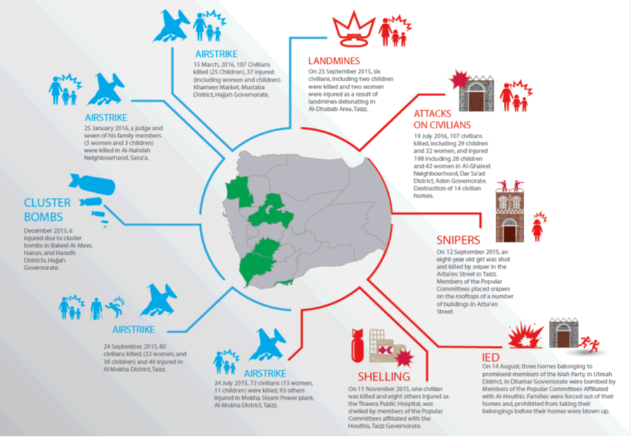

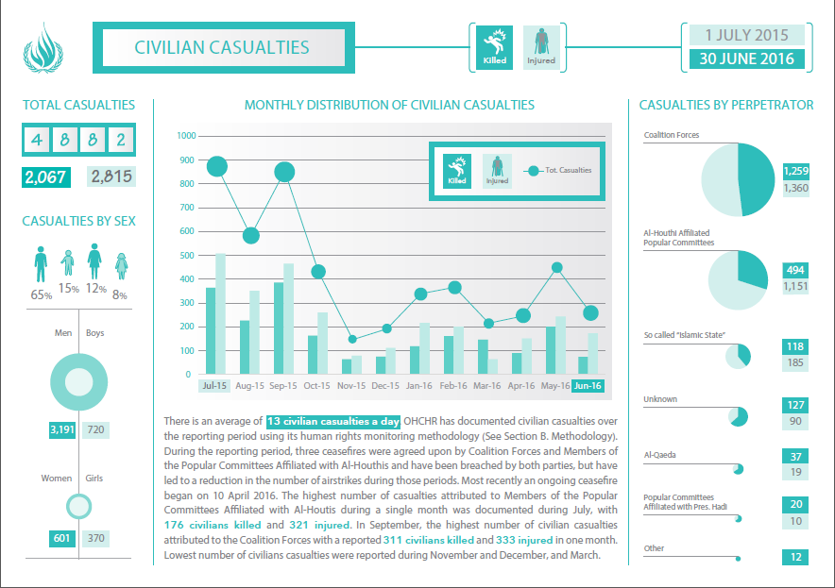

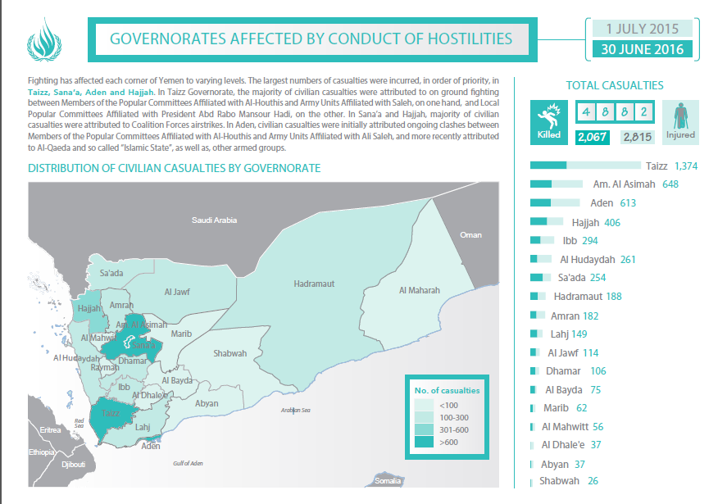

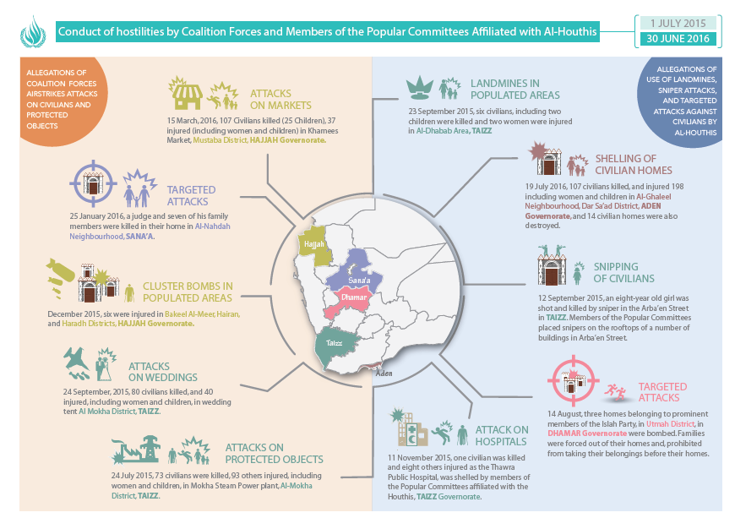

Annex III

United Nations Educational, Scientific and Cultural Organization list of cultural sites in Yemen   
that have been damaged

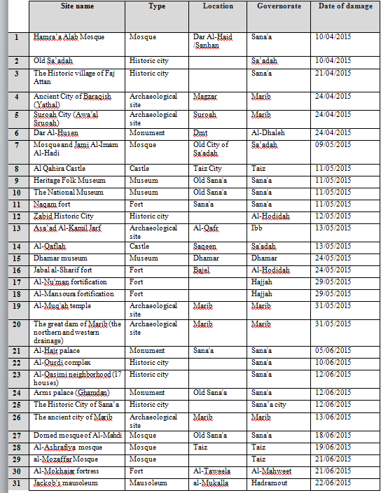

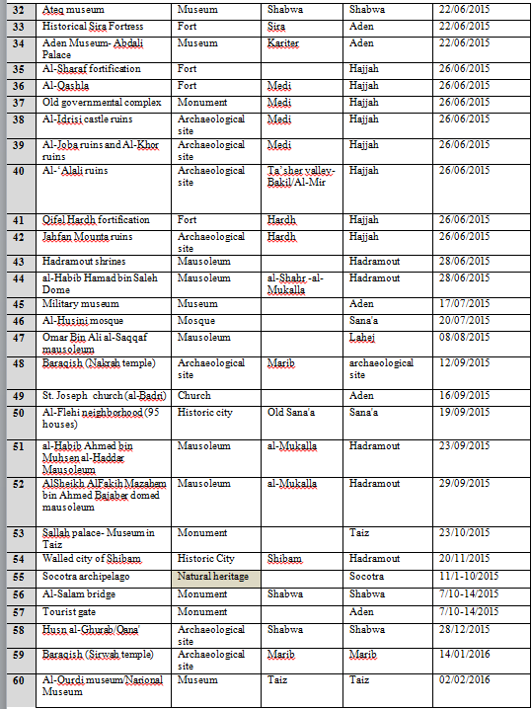

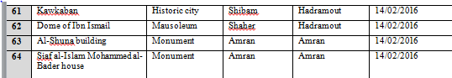

1. * The annexes to the present report are circulated as received, in the language of submission only.
2. Aden, Amran, Dhale’e, Hadramout, Hajjah, Hodeidah, Mareb, Sana’a Governorate, Shabwa and Taizz.
3. A total of 194 reports were submitted by 37 national organizations and 67 reports were submitted by 7 international organizations. Three United Nations agencies provided reports.
4. The coalition consists of all the States members of the Gulf Cooperation Countries (with the exception of Oman), as well as Egypt, Jordan, Morocco, Senegal and the Sudan.
5. See annex I, section A, for additional information on political developments and humanitarian conditions.
6. See annex II for infographs on casualties recorded by OHCHR.
7. See annex I, section B, for more information on attacks on residential areas.
8. All photographs contained in the report were taken by staff of the Office of the United Nations High Commissioner for Human Rights.
9. See annex I, section C, for information on other attacks on markets documented by OHCHR.
10. See annexI, section C,for information on other attacks on weddings documented by OHCHR.
11. See annex I, section C, for information on other attacks on residential buildings documented by OHCHR.
12. See annex I, section C, for information on other attacks on public and private infrastructure documented by OHCHR.
13. See International Committee of the Red Cross (ICRC), Practice Relating to Rule 81: Restrictions on the Use of Landmines (2016) and ICRC, Rule 71: Weapons That Are by Nature Indiscriminate.
14. See annex I, section D, for information on other attacks by armed groups documented by OHCHR.
15. Ananya Roy, “14 suspected al-Qaeda militants killed by US drone attacks in Yemen”, *International Business Times*, 28 March 2016. Available from www.ibtimes.co.uk/14-suspected-al-qaeda-militants-killed-by-us-drone-attacks-yemen-1551811.
16. See annex I, section E, for information on other attacks on medical facilities and personnel documented by OHCHR.
17. See rule 25, on medical personnel, and rule 28, on medical units, of customary international humanitarian law described by ICRC, which provide a higher threshold of protection under international humanitarian law.
18. See annex I, section E, for information on other attacks on historic or cultural sites and places of worship documented by OHCHR.
19. Rule 38 of customary international humanitarian law provides that each party to the conflict must respect cultural property. Specifically, special care must be taken in military operations to avoid damage to buildings dedicated to religion, art, science, education or charitable purposes and historic monuments unless they are military objectives, and property of great importance to the cultural heritage of every people must not be the object of attack unless imperatively required by military necessity. Cultural sites are also protected under international human rights law, including under article 27 of the Universal Declaration of Human Rights and article 15 of the International Covenant on Economic, Social and Cultural Rights, which protect the right of everyone to take part in cultural life.
20. See annex I, section E, for information on other attacks on educational facilities documented by OHCHR.
21. See annex I, section F, for information on other cases of deprivation of liberty.
22. OHCHR documented cases of detention of fighters but did not document allegations of violations of international humanitarian law. OHCHR is also monitoring the exchange of fighters between the parties to the conflict.
23. In a report published in 2016, Amnesty International indicated that at least 11 journalists were currently being held by Houthi forces. See Amnesty International, “Where is my father? Detention and disappearance in Huthi-controlled Yemen” (London, 2016). The Yemeni Observatory for Human Rights mentioned in its reports submitted to OHCHR, dated February 2016, that 13 journalists remained deprived of their liberty.
24. Detention centres in the governorates of Hodeidah, Sana’a, Aden, Ibb, Taizz, Hadramout and Shabwa.
25. Six letters were sent to the Ministry of the Interior, five to the Political Bureau of Ansar Allah, three to the office of the President, two to the General Prosecutor, two to the head of security forces of Sana’a city, two to the National Security Bureau, two to the president of the Houthi high revolutionary council, one to the high judicial council and one to the Ministry of Foreign Affairs.
26. The Studies and Economic Media Center, in its report *Media Freedom Violations Report Yemen 2015*, reported that 14 journalists had been killed in 2015, that 254 journalists had been deprived of liberty and that 46 media institutions and journalists’ houses had been attacked.
27. The incident was further corroborated by open sources, including videos.
28. The country task force on monitoring and reporting, established in the context of the monitoring and reporting mechanism on grave violations against children in situations of armed conflict, comprises 15 United Nations agencies and international non-governmental organizations, and currently covers 50 districts over 10 governorates.
29. United Nations Children’s Fund (UNICEF), *Children on the Brink: The Impact of Violence and Conflict on Yemen and Its Children* (2016). Available from [www.unicef.org/media/files/  
    Yemen_FINAL.PDF](http://www.unicef.org/media/files/Yemen_FINAL.PDF). See also the country task force contribution for the present.
30. Country task force contribution for the present report.
31. INTERSOS, “GBV trend analysis 2015: incident reporting by 30 local associations to INTERSOS- UNFPA for 8 governorates, Aden, Lahj, Abyan, Shabwa, Al Dhalea, Amran, Sada’a and Hajjah” (December 2015).
32. See the Guiding Principles on Internal Displacement and Human Rights Council resolution 20/9.
33. Security Council – Chronology of Events (<http://www.securitycouncilreport.org/chronology/yemen.php>).
34. OHCHR bi-monthly report: 11-24 September 2015.
35. OHCHR bi-monthly report: 25 September – 8 October 2015.
36. OHCHR Monthly Report February 2016.
37. OHCHR bi-monthly report: 14-27 August 2015.
38. OHCHR Monthly Report October 2015.
39. UNESCO.
40. OHCHR.
41. UNESCO.
42. OHCHR.
43. OHCHR.
44. UNESCO, OHCHR.
45. Social media websites allege that Islamic State in Sana’a has claimed responsibility for the attack. The mosque incurred partial damage.
46. This incident was also documented by Human Rights Watch, Amnesty International and Mwatana.Amnesty International, Where is my father?:detention and disappearance in Huthi-controlled Yemen, May 2016, p.26, [ <https://www.amnesty.org/en/documents/mde31/4006/2016/en/> ]Human Rights Watch, Yemen: 3 Months Since Houthis ‘Disappear’ Protesters, 16 January 2016, [<https://www.hrw.org/news/2016/01/16/yemen-3-months-houthis-disappear-protesters>] Mwatana Organisation for Human Rights, They Are Not Here, 12 May 2016, p.38.
47. Amnesty international also mentioned that it “is aware of at least three men whose whereabouts remain unknown as of May 2016”. Amnesty International, Where is my father? detention and disappearance in Huthi-controlled Yemen, May 2016, [https://www.amnesty.org/en/documents/mde31/4006/2016/en/].
48. In the pre-trial detention facility, in Sana’a, the OHCHR staff interviewed 10 detainees that have been in detention for four months, no charges were brought against them or were investigated with. The acting manager of Al Thawra detention facility informed OHCHR that these detainees were detained by members of the Popular Committees and he does not have the authority to release them or refer them to the investigative judge
49. OHCHR corroborated information from three different independent sources: a co-detainee that witnessed the incident, Deputy Director of the detention centre and Hajja Attorney.